STOP TYPE

--------------------

'01-Permanent'

'01-SP death and no family benficiery';

'01-death of family pensioner';

'01-transfer to other district/state';

'01-minor pensioners after 25 years age';

'01-avc not submitted > 3years';

'01-Family Pensioner is re-marriage';

'02-Temporary';

02-pc.mr medical certificate not submitted'

02-death of service pensioner

02-Objections by PIA/Courts etc

02-Guardianship of Minor completed

02-Guardian of Minor expired

02-Paybank closed

02-voluntary request by pensioner

'03-Release';

03-pc.mr medical certificate submitted'

03-converted to family'

03-Objections overrule PIA/Courts etc

03-Minor pensioner account opended'

03-another guardian of Minor submitted'

03-another paybank was opened'

03-release pension request by pensioner

'04-No Familypension';

04-No Further Family Pensions

t



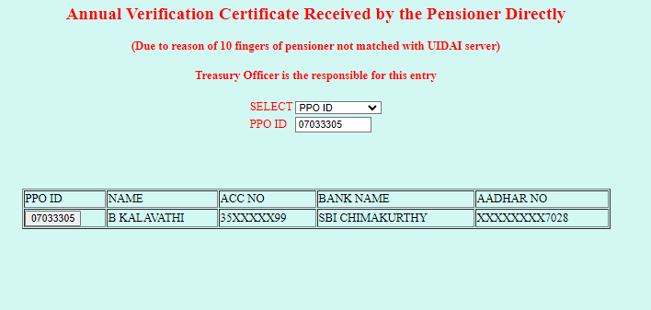

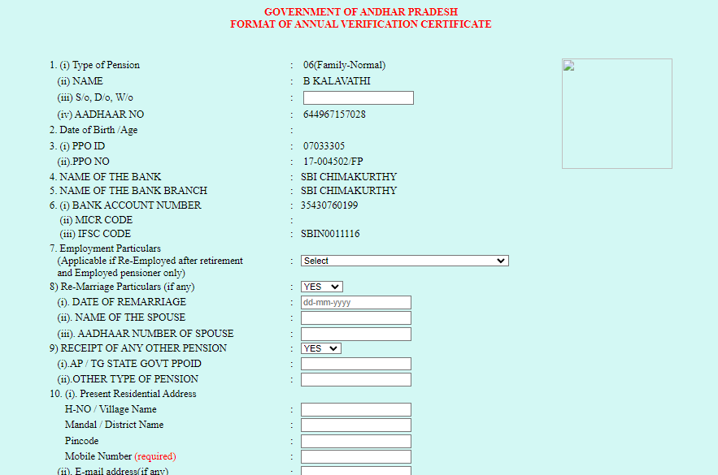

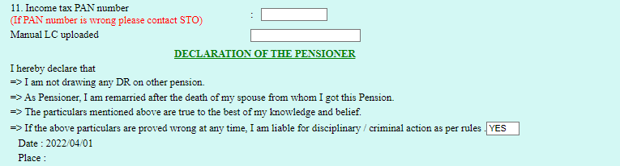

Select VALUES FOR EMPLOYEE REEMPLOYEEMENT PARTICULARS FROM REEMPLOYEEMENT TABLE

Dr AVAILABILITY

REEMPLOYEEMENT STATUS DR IR MA

1. Not employed after retirement yes yes yes

02 Selected by appropriate Recruitment Agency yes no no

03 Private employee yes yesyes

04 Public Sector employeeyes yesyes

05 compasinate employment no nono

06 consolidated salaryyes yesyes

07 Govt Employee but salary not through HRMSyes yesyes

IN PPO_AVC TABLE NODA STATUS AS 0--dryes,1—drno